Multi-modal autonomous beamline experimentation

Kevin H. Stone – SSRL Materials Sciences Division

The goal of this proposal is to create an infrastructure for autonomous beamline experiments utilizing multi-modal approaches at SSRL. This multi-modal approach can be incredibly general, whether it be machine learning assisted data acquisition, multi-resolution capable setups, or backend analysis driven automation. In a recent proof-of-concept experiment at beamline 2-1 (Figure 1) we utilized a 2-detector setup and clever Python scripting to automate high quality data acquisition. Automated analysis of the fast, low resolution data was used to autonomously collect slower, high resolution data only in the information rich regions around diffraction peaks. These multi-modal approaches will start at diffraction beamlines (***BL2-1, 10-2a, 11-3***), yet the infrastructure will be written in a generalizable manner to test automated experimental approaches for most X-ray synchrotron diffraction methods at SSRL.

We wish to use the funding in this proposal to flesh this into a full project where *in situ/operando* experiments at the beamlines can be fully automated, making experimental decisions on-the-fly without user intervention. The funding would also enable collaborations to incorporate machine learning for automated phase identification for improved data acquisition. Another example is incorporating on-the-fly Rietveld analysis to make experimental decisions based on structural evolutions of reacting phases. These experiments are the next steps for the future of synchrotron experiments by fully utilizing beamtimes not wasting any time associated with data analysis before proceeding in the experiments. Proceeding the LDRD we wish to use the project to pursue greater funding to increase the efficiency of meaningful data collection of each associated beamline without increasing beamline energies.

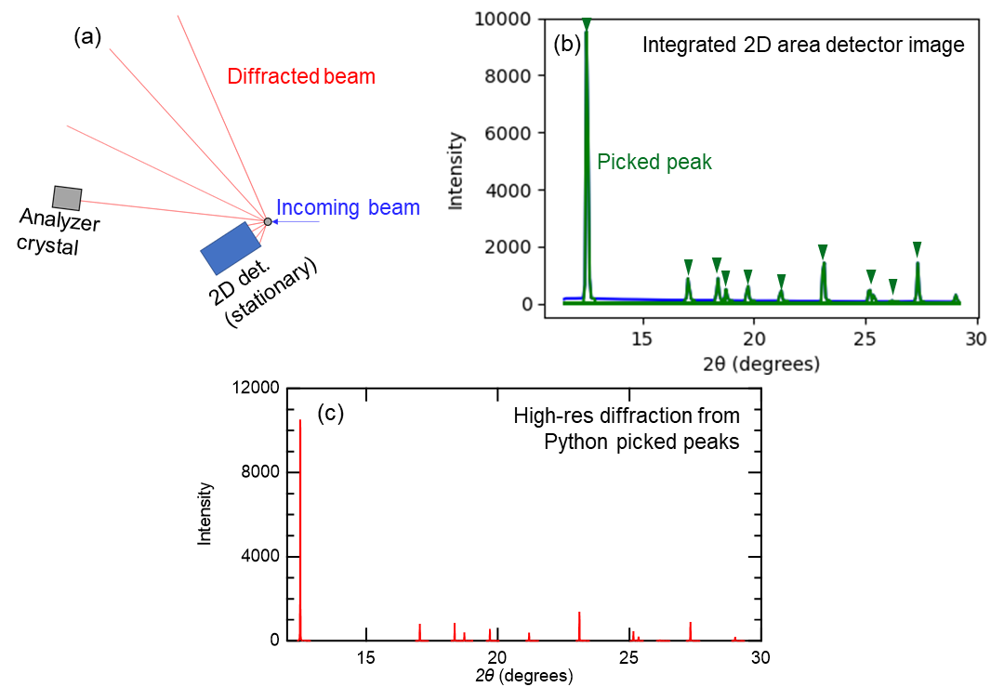

Figure 1: (a) 2-detector multi-resolution beamline setup. 2D area detector (blue) collects low resolution scans (b) for which peaks are picked by the Python script, highlighted in green, and are scanned by the analyzer crystal collecting the pattern (c) in 25 minutes apposed to 75 minutes. This proof of concept was applied on quartz (shown) and LaB6 samples.